Create a Virtual Hard Disk and allocate the storage using VM ware Workstation.

Procedure:

Step1: Creating a Virtual Hard Disk and allocating the storage using VMWare workstation.

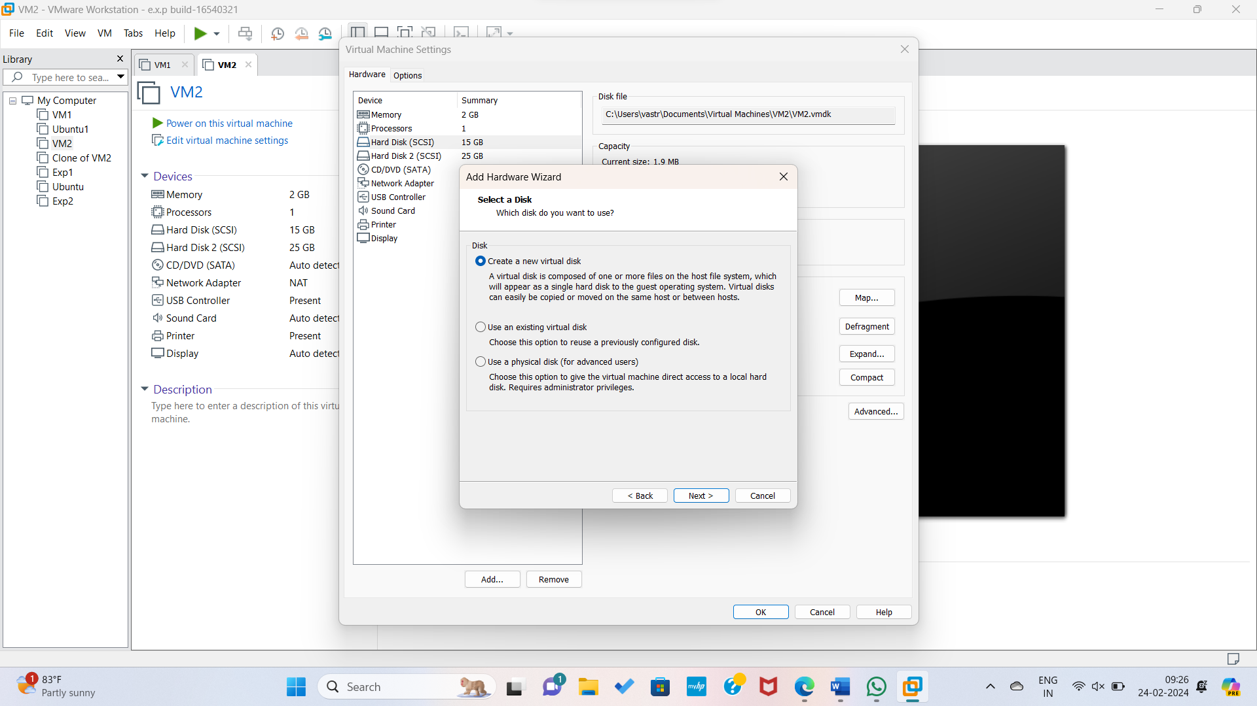

Step2: Adding a new hard disk to the Virtual machine.

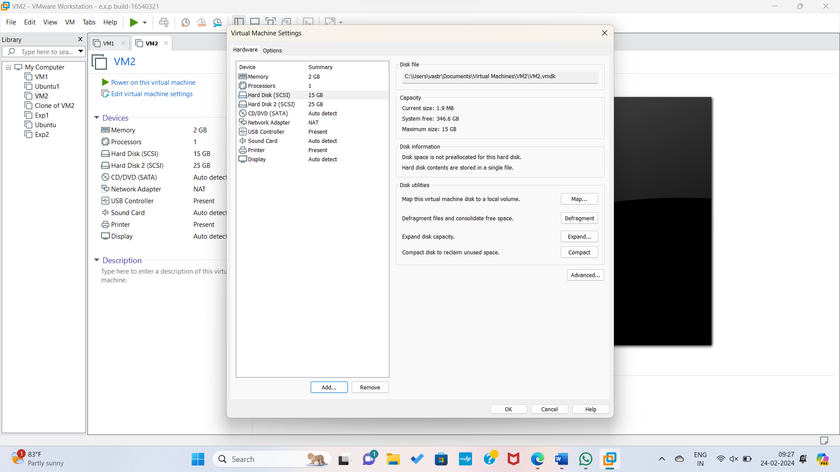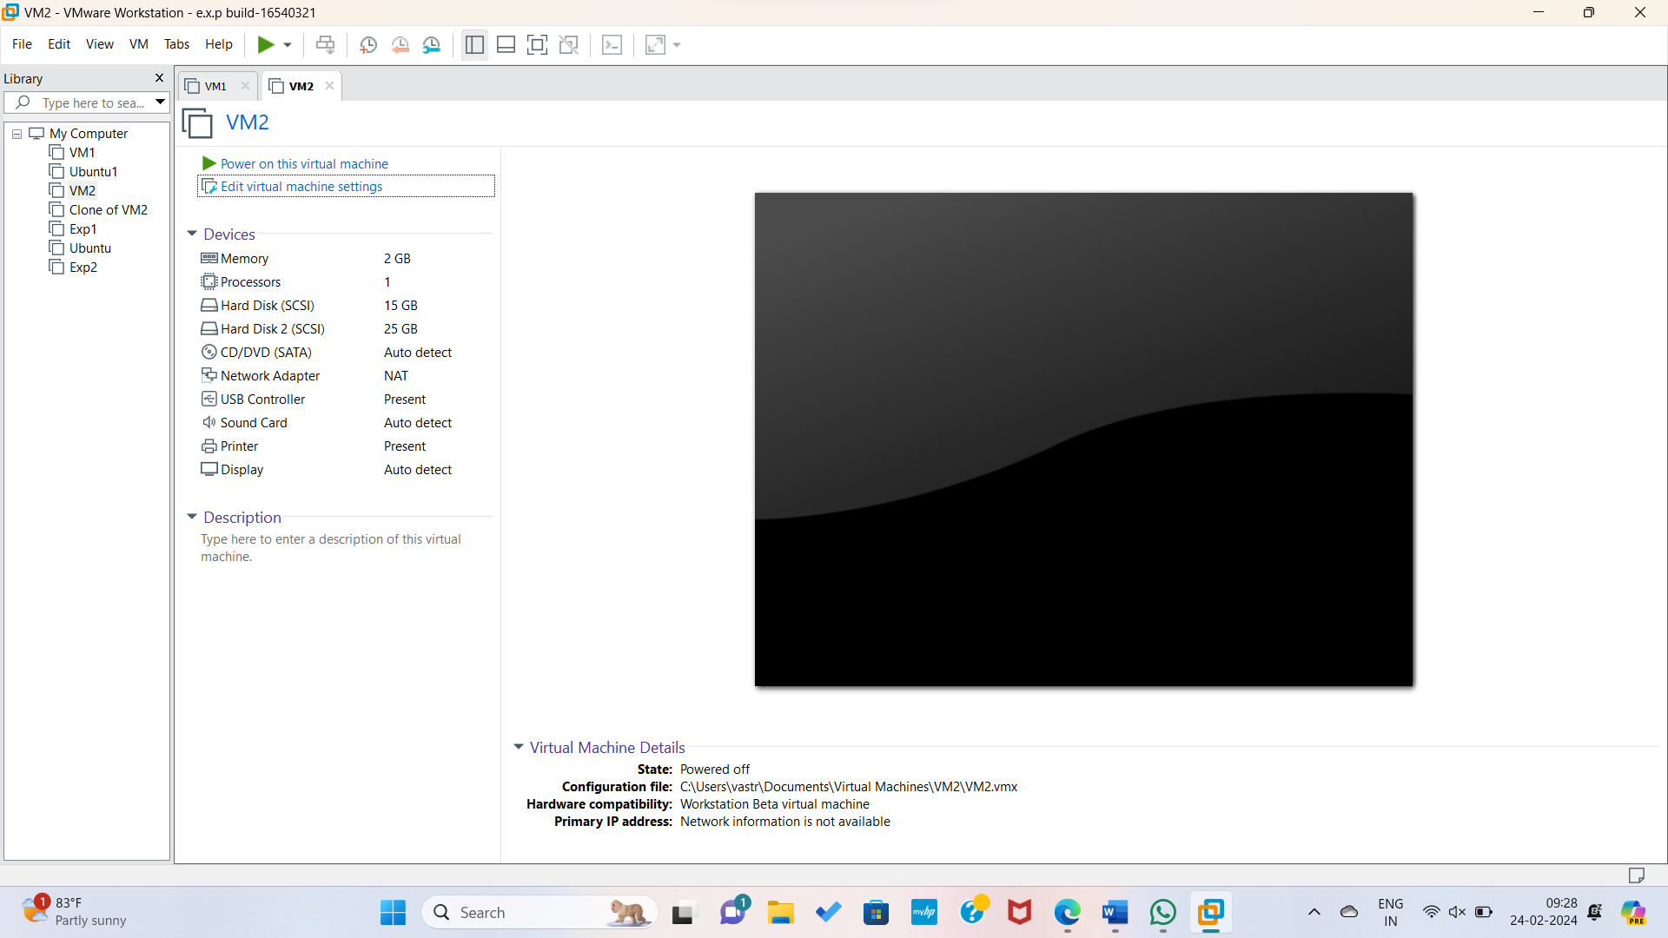Hence the Hard Disk Added Successfully to the Virtual Machine Workstation.